
Wholesale
restaurant favourites
with an
ethical twist

Hand Sourced is a one-of-a-kind, grass-roots level niche supplier that delivers authentic rare, endangered, and heritage lines of poultry, meat, and fully wild harvested game directly from farmers and harvesters. We are committed to small, boutique Australian producers who breed, raise and process on farm; and maintain chemical free chains from conception to finished product. Our wild game is grazed on natural bushland; harvested at night, and ethically processed. ALL our animals are chemical and synthetic feed free, live active, outdoor lives, and are processed using air chilling and hand finishing techniques. Chemicals and chlorine are not permitted in any of our affiliated abattoirs. We return 100% of the costs to the producer and currently support 9 small family farms across Australia.

Natural breeding cycles.
The "big deal" about on-farm poultry breeding is that most Aussie farms no longer join (breed) on their own land, electing instead to buy young to raise and sell. The Australian farming system is supported by large, intensive factory farming corporations that house parent breeding stock in large indoor sheds and cultivate to sell young livestock and day-old poultry to small scale farms that then grow and label as 'free range,' 'organic,' ‘regeneratively farmed’ or 'pasture raised'. The purchase of those animals can still support large-scale production of intensively bred stock. You need to consider the breeds, and where the breeding occurs, to support an ethical change.

We offer an alternative: farmers who have spent years working with genetics, and breed progeny on farm to develop full blood produce.
Led by sole trader, Shirley Harring, Hand Sourced operates in complete transparency, with an unwavering focus on the farmers with whom we collaborate, and we take our responsibility to supply premium quality produce seriously. No chemicals, hormones, additives, or nasties. Our small family-owned business has been recognised by ABC Landline, Australian Food Sovereignty, AHA, and Telstra Business for its contribution to ethical food supply. In 2024, we moved our cold stores to Sydney to help our rural based small-scale producers reduce food miles.
If you would like to see all products available to you as a Public Wholesale customer, please email me on shirley@handsourced.com.au. I am much more than pretty pictures!
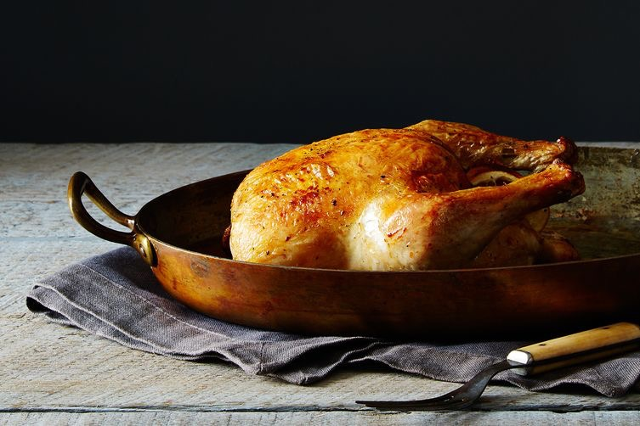

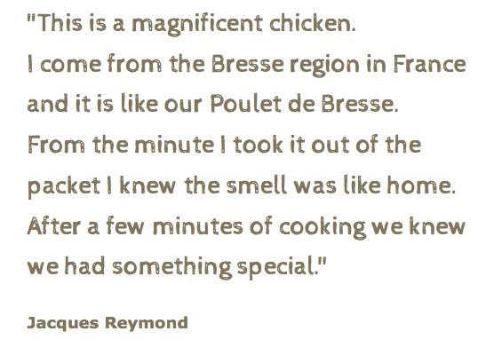

Heritage Breed
Poultry

Preserving Genetics: Heirlooms are traditional varieties of fruit and vegetables that are not always readily available, such as beefsteak tomatoes and kipfler potatoes. These are traditional plant varieties that were popular prior to industrial-scale farming. You would have discovered them in your grandparents' gardens.

Heritage breeds are the livestock equivalent of heirloom vegetables, - the type of meat and poultry that your grandparents might have raised. Heritage breeds grow longer, live better, natural lives without crossbreeding genetic problems. And - Heritage breeds taste better.

All birds are processed, hand finished, and hand packed on farms without the use of bleach or chemicals, and labelled by the farm on which they are grown.

- Small family farms

- Ethically managed,
regeneratively farmed

- Award winning

- Hand processed,
finished and packed on farm.

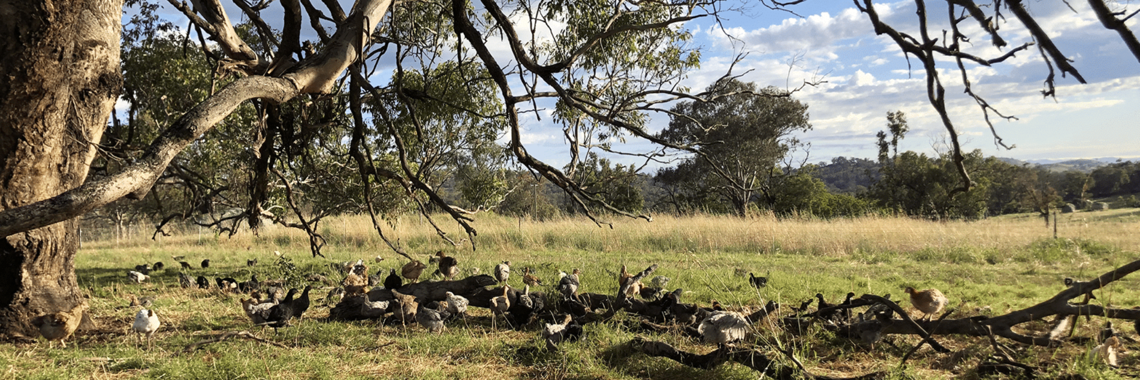

Grassland Poultry Heritage Sommerlad Chickens, NSW

Chicken

Almost all small farm and meat chickens in Australia grow Cobb/Ross breeds known as 'white broilers' (with an 'r'). White broiler chickens, including organic, are slaughtered at a young age and rarely live past 6 weeks.

We stock only heritage/rare breed chicken. It’s a pricier product because it’s not commercially altered for the meat market and is allowed to grow for three times as long as conventional poultry. We prefer natural heritage birds that thrive outside in Australian conditions and live a long, natural life.

They look, cook, and taste completely different.

Instructions and Ordering Guide:

For wholesale cartons of a single product, please use the links provided on each product. If a product isn’t linked, you can order wholesale cartons by emailing me directly.
Pricing provided on the website is for whole cartons of single product.
Pricing provided in this document is for mixed cartons, regardless of size. Discounts may apply to larger quantities.

Creating a mixed carton:
- Any item below can be added to a whole mixed carton. Please choose by the kg (i.e. 5kg breasts) or the unit (1 x 2.5kg chicken; 2 x single pies) to fill a 7-9kg, or 14-15kg total. Instructions are available here.
- Be sure to include a ‘flexi item’ — this is any item from the list below that the farmer can use to fill any remaining space in your carton to ensure it’s packed to capacity. A full explanation is provided in the directions.

When you’re ready to place your customised mixed carton order, head here.

Information:
About Grassland’s Sommerlad Heritage Chicken
About the use of bleach in chicken processing
Quick Cooking Guide
Histamine Friendly
Recipes and more

Grassland Sommerlad Heritage Poultry Pricelist: Public Wholesale October 2026
Please note: Prices below apply to custom mixed cartons. Full cartons of a single product attract a discount reflected on our website. Example: A full carton of chicken breasts costs $42.60/kg via the website. The same product as part of a mixed carton is $44.10/kg. View each product on the website by clicking on the blue hyperlink provided. Bags are vacuum sealed double strength.
F
Product | Size per unit |  | Order Notes | PPK
Raw Product: Whole Birds
Feet and heads can be left on by request.
Tip: Save your bones in the freezer then simmer slowly for deep, rich stock — the foundation for soups, sauces, or risottos.
Sommerlad Heritage Chicken  Whole chickens  Grown 14-16 weeks | 1.5–3.0kg per bird |  | Request in 300g increments:  XS: 1.5kg-1.7kg avg  S: 1.8kg-2.0kg avg  M: 2.1kg-2.3kg avg  L: 2.4kg-2.6kg avg  XL: 2.7kg-2.9kg avg  J: 3.0kg + *extended wait time on large birds | $29.91kg
Sommerlad Heritage  Roosters or cockerels  Grown 16-20 weeks  Mature Rooster Whole  Grown 20+ weeks *when available | 2.5-3.8kg per bird |  | Request in 300g increments as above (2.5 upwards)  *extended wait time applies until 2027 | $29.91kg
Halved or Quartered on the frame  All sizes as outlined above, halved or quartered |  |  |  | $32.99kg
Whole boneless rolled (Ballotine)  Something for celebrations, a small ballotine will easily feed 6 people. | To order |  | Request from 1.3kg-1.7kg ea. | $67.99kg
Raw Product: Portions

Sommerlad Heritage Breasts, skin on – skinless by request  One breast per person is more than ample. Moist and easy to cook. Great for pan frying, simmering, or kid’s nuggety snacks. | Skin on packed in pairs; skinless packed in 1kg bags.  2 breasts equal approx. 450-550kg. |  | Order by the pack (pair) or the kilogram. Specify skin on or skin off. Skin on is the default. | $44.10kg
Sommerlad Heritage Tenderloins  Great for pan frying, simmering, or kid’s nuggety snacks. | Packed in 500g or 1kg bags. |  | Order by the pack the kilogram. | $44.10kg
Sommerlad Heritage Marylands  Marylands are large, one per person is ample. Succulent dark meat perfect for roasting, grilling, or slow braising for deep, flavourful meals. Save your bones! | Packed in pairs.  Typically, 300-400g per maryland, though sizes vary. |  | Order by the pack (pair) or the kilogram. | $44.10kg
Sommerlad Heritage Drumsticks  Juicy and full of flavour, drumsticks are perfect for marinating and roasting, grilling, or slow cooking. Save your bones! | 1kg bags |  | *Limited to 5kg per order.  Order by the kilogram. | $29.99kg
Sommerlad Heritage Wings  Large and succulent, perfect for finger food. Simply season with your favourite rub and roast for a Friday night fake-away. Save the bones! | 1kg bags |  | Order by the kilogram. | $23.99kg
Sommerlad Heritage Chicken, Minced  Premium mince with a balanced mix of dark and light meat, plus natural fat for flavour. | 500g or 1kg bags |  | Order by the kilogram and specify your bag size. | $36.99kg
Sommerlad Heritage Chicken: Thigh cutlets on the bone  The ‘ribeye fillet’ of the chicken world: tender dark meat with a beautiful crispy skin. Perfect for roasting, pan-frying, or adding depth to slow-cooked dishes. Rich in flavour and quick to prepare. Save your bones! | 1kg bags – usually 5-6 cutlets |  | Order by the bag or by the kilogram. | $66.23kg
Offal and Bone:

Sommerlad Heritage Chicken, Liver | 500g bags |  | Order by the pack or by the kilogram | $32.99kg
Sommerlad Heritage Chicken, Hearts | 500g bags |  | Order by the pack or by the kilogram | $20.99kg
Sommerlad Heritage Chicken, Giblets | 1kg bags |  | Order by the pack or by the kilogram | $28.99kg
Sommerlad Heritage Chicken, Necks skinless | 1kg bags |  | Order by the pack or by the kilogram | $16.49kg
Sommerlad Heritage Chicken, Feet  Rich and gelatinous, chemical and chlorine-free feet add natural body to soups, stews, and broths. The secret to deeply flavoured, silky stock, they’re ideal for slow simmering and long cooking. | 1 kg bags |  | Order by the pack, or by the kilogram. | $19.99kg
Sommerlad Heritage Chicken, Heads | 25 per bag (vac packed) |  | Order by the pack, or by the number of heads. | $0.85 per head
Sommerlad Heritage Chicken, Frames/carcasses  (Standard)  Meaty with some skin attached, frames are perfect for soups, stocks, and stews. Combine with feet and necks for maximum nutrition and a rich, deeply flavoured broth.  (Breeder) *when available  Includes wings, drumsticks, and thigh bones, offering higher yield than standard frames. Perfect for stocks, broths, or slow-cooked soups. | Standard: 2 per bag  1-1.5 kg bags  Breeder: Bulk packed, 5kg per liner bag (not vac packed) |  | Standard:  Order by the pack or by the kilogram.  Breeder frames only available in bulk (8-10kg). 10% discount available. | $17.99kg
Sommerlad Heritage Chicken, Skin (with fat) | 500g-1kg bags |  | Bag sizes vary due to the yield that is processed. Order by the 500g increment.  Standard skin as stripped from frame | $19.99kg
Sommerlad Heritage Chicken, Neck Skin (lean) | 500g-1kg bags |  | Bag sizes vary due to the yield that is processed. Order by the 500g increment.  Neck skins – whole, cleaned skin tubes | $32.14kg
Sommerlad Heritage Chicken, unrendered fat | 1 kg bags |  |  | $19.99kg
Ready to Cook Product:

Sommerlad Heritage chicken: Handmade meatballs (GF)  100% Chicken, White pepper, salt, GF crumb | 250g or 500g trays | Order in 500g lots |  | $43.25kg
Sommerlad Heritage chicken: Handmade rissoles (GF)  100% Chicken, White pepper, salt, GF crumb  Juicy and versatile, they pair beautifully with a quick garlic, sumac, lemon, and yoghurt dip for an easy, crowd-pleasing snack. | 250g or 500g trays | Order in 500g lots |  | $43.25kg
Sommerlad Heritage chicken: Meatloaf (GF)  100% Chicken, White pepper, salt, GF crumb  These meat loaves are wonderful, gluten-free, and family friendly. One meatloaf will easily feed a family with leftovers. The flavour is great, and all the hard work is done for you. | Per 500g loaf | Order per loaf |  | $32.49ea
Sommerlad Heritage chicken: Schnitzels (GF)  100% Chicken, White pepper, salt, GF crumb  Keep in the freezer for one of those nights when everything is too hard. Our family favourite: top with leg ham, lots of grated cheese and Sugo and make our own fake away Parmies. All the nutrition and none of the nasties. | Packed in pairs  250g p/pack | Order per 250g pack. |  | $62.49kg
Sommerlad Heritage chicken: Handmade sausages (GF)  100% Chicken, White pepper, salt, GF crumb | Per 500g | Order per 250g |  | $43.28kg
Chicken & Leek Pot Pies: Chicken, leek, white pepper, salt, Sommerlad bone broth, flour, cream, egg. Caremé pastry base.  Every pie made on farm by farmer Bryan.  Pie: Family: | 800g avg ea | Order per pie |  | $51.18 ea
Pie: Single: | 240g avg ea | Order per pie |  | $16.99 ea
Sommerlad Heritage chicken: Purified Rendered fat/ Schmaltz; (500ml Jar)  100% chicken fat  Use this to make the crispiest roast potatoes you’ve ever had. | 500ml jar | Order per jar |  | $19.99 ea
Sommerlad Heritage chicken: Whole smoked chickens |  | Unavailable until further notice
Sommerlad Heritage chicken: smoked chicken portions |  | Unavailable until further notice
Sommerlad Heritage chicken: Broth  A very light version of chicken broth. | 1 litre pouch | Order per pouch |  | $27.99 ea

Packed Mixes: order by the box (7-8kg or 15kg)
Sommerlad Heritage Chicken,  Broth Box  A farm-curated mix of necks, feet and frames. Perfect for soups and broths. | 500-1 kg bags | Order by the box (7-8kg or 15kg) | $16.49kg
Sommerlad Heritage Chicken,  Offal Box  A pre-curated mix of hearts, liver and giblet. Perfect for offal lovers. | 1 kg bags | Order by the box (7-8kg), prices above

Pet Food (7-8kg or 15kg)
Sommerlad Heritage chicken: Handmade mince  Hand minced, includes cartlidge, soft bone, etc | 1kg bags | Min qty 8-9kg box | $16.49kg
Sommerlad Heritage chicken: Chicken heads | Bulk packed | Min qty 8-9kg | $0.75 per head

How to get your order to me:

You can either print and scan the order form on the following page or simply send me an email. Please include your order number (beginning with W) and let me know the contents of your preferred carton.

I’ll always come back to you with suggestions to help you get the best value for your order, and I’ll confirm how your quantities work out.

Don’t forget to add your Flexi item – it’s essential. Remember to fill a 7-9kg, or 14-15kg carton. Instructions are available here.

Order Form
Customer Name:
Email Address:
Order Number (#W):

Raw Product: Whole Birds
Product | Size per unit | Price | Order notes
Sommerlad Heritage Chicken - Whole chickens  *specify if you desire H, F on; or if halved or quartered. Default is whole dressed chicken | 1.5–3.0kg per bird  XS; S; M; L; XL; J | $29.91kg
Sommerlad Heritage Roosters or Cockerels | 2.5–3.8kg per bird | $29.91kg | Currently unavailable
Mature Rooster Whole (when available) | 2.5–3.8kg per bird | $32.99kg
Whole boneless rolled (Ballotine) | 1.3–1.7kg ea | $67.99kg

Raw Product: Portions
Sommerlad Heritage Breasts | Skin on pairs /  Skinless 1kg bags | $44.10kg
Sommerlad Heritage Tenderloins | 500g or 1kg bags | $44.10kg
Sommerlad Heritage Marylands | Packed in pairs | $44.10kg
Sommerlad Heritage Drumsticks | 1kg bags | $29.99kg
Sommerlad Heritage Wings | 1kg bags | $23.99kg
Sommerlad Heritage Chicken, Minced | 500g or 1kg bags | $36.99kg
Sommerlad Heritage Chicken, Thigh cutlets on bone | 1kg bags | $66.23kg

Offal and Bone
Sommerlad Heritage Chicken, Liver | 500g bags | $32.99kg
Sommerlad Heritage Chicken, Hearts | 500g bags | $20.99kg
Sommerlad Heritage Chicken, Giblets | 1kg bags | $28.99kg
Sommerlad Heritage Chicken, Necks | 1kg bags | $16.49kg
Sommerlad Heritage Chicken, Feet | 1kg bags | $19.99kg
Sommerlad Heritage Chicken, Heads | 25 per bag | $0.85 per head
Sommerlad Heritage Chicken, Frames (Standard) | 2 per bag, 1–1.5kg | $17.99kg
Sommerlad Heritage Chicken, Frames (Breeder, bulk) | 5kg liner bag | $17.99kg
Sommerlad Heritage Chicken, Skin (with fat) | 500g–1kg bags | $19.99kg
Sommerlad Heritage Chicken, Neck Skin |  | $32.14kg
Sommerlad Heritage Chicken, Unrendered fat | 1kg bags | $19.99kg
Sommerlad Heritage Chicken, Broth pouches (1l) | 1L | $27.99ea

Packed Mixes
Sommerlad Heritage Chicken, Broth Box 7-9kg | 15kg | 500g–1kg bags | $16.49/kg
Sommerlad Heritage Chicken, Offal Box | 1kg bags | See website

Ready to Cook Product
Handmade meatballs (GF) | 250g or 500g trays | $43.25kg
Handmade rissoles (GF) | 250g or 500g trays | $43.25kg
Meatloaf (GF) | 500g loaf | $32.49ea
Schnitzels (GF) | 250g packs (pairs) | $62.49kg
Handmade sausages (GF) | Per 500g | $43.28kg
Chicken & Leek Pies - Family | 800g avg ea | $51.18 ea
Chicken & Leek Pies - Single | 240g avg ea | $16.99 ea
Purified Rendered fat / Schmaltz | 500ml jar | $19.99 ea
Sommerlad Heritage Chicken: Broth | 1 litre pouch | $27.99 ea

Pet Food
Sommerlad Heritage Chicken, Mince Box 7-9kg | 15kg | 500g–1kg bags | $16.49/kg
Sommerlad Heritage Chicken, Heads | Bulk packed | See website

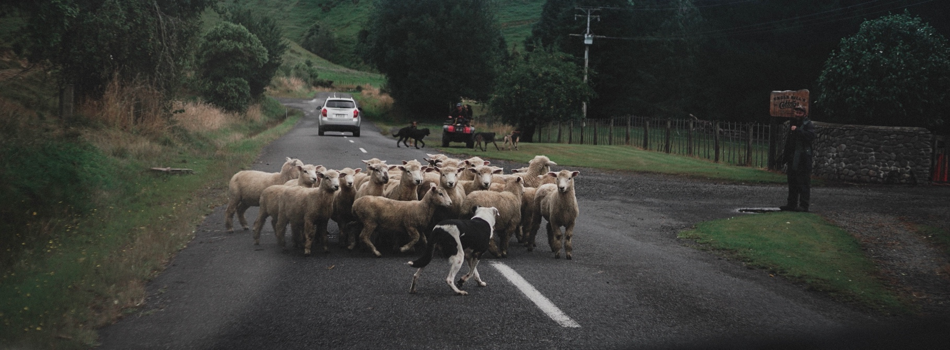

Ordering and deliveries

Orders can be placed via the website www.handsourced.com.au
24 hours a day, 7 days a week.
Customised orders – email me.

Metro deliveries arrive Monday-Friday 8am-6pm.
Weekend or 12.00am-07:00 am deliveries can be arranged by request.
Please read and understand the delivery details for all home deliveries

We use a logistics company for deliveries.
Delivery days may vary and can be altered to suit your needs; however, couriers can reroute at their own concern.

You will be sent a tracking number, please provide a mobile phone number.

SA | VIC | NSW | ACT | QLD | WA | TAS | NT Delivery up to 2 cartons

- Metro delivery $40.00 + GST ($15.00 per carton thereafter)
- Rural delivery $55.00 + GST ($18.00 per carton thereafter)
- Check the delivery page for information.
- Please note some products will show additional farm delivery costs, these may be proportioned to your overall delivery.

Deposits are required for all orders with all balances due before or at the time of delivery.

Item pricing in this catalogue is for public wholesale members only
Products are sold in line with our terms and conditions and delivery terms.
Produce is sold by final weight unless otherwise listed.

Contact Shirley with any questions on how to get the best value on your wholesale purchases

0419714274

orders@handsourced.com.au

handsourced.com.au

Facebook & Instagram

@handsourced

Reading this online? Follow the hyperlinks to…
Meet the producers
See how we work
Find delivery areas
Sign up for our Newsletter

We acknowledge that we meet and work with farmers, producers and harvesters on Indigenous lands across this nation and that sovereignty of the land was never ceded.
We pay respect to elders, past and present, and acknowledge the pivotal role that Aboriginal and Torres Strait Islander people continue to play within the Australian community.

